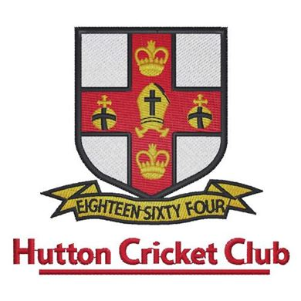
Hutton Cricket Club Kit Order Form (Men’s)

The following form allows you to order the new playing shirt for next season that is provided free of charge as part of your annual subscription.

You will see it is blacked out at Zero cost, all other items can be ordered for delivery asap and of course they will not incur delivery charges if ordered in this way, items other than the Coloured Shirt for adult 50 over and T20 cricket will also be available to order directly via the new club shop, link below, there will also be a link on the Club Website if you prefer.
https://teamwear.nxt-sports.com/shop/huttoncc

Anyone wishing to purchase the new Colour Kit is welcome but all 1st team 50 over games will be played in colour kit as will the 1st team and U19 T20 competitions so if you are wishing to be selected for these formats you will need to purchase at least trousers and shirt (Jumpers are optional but may be needed).

Sizing will be the responsibility of each member and all exchanges will be chargeable, we will have some items available for sizing.

Item | Size (please circle) | Price
White playing Shirt Short Sleeve | X Small Small Medium,  Large X Large XX Large | £0
White playing Shirt Long Sleeve | X Small Small Medium,  Large X Large XX Large | £34
White playing Shirt Long Sleeve INSTEAD of Short Sleeve | X Small Small Medium,  Large X Large XX Large | £5
Coloured Short Sleeve Shirt Men’s fit | X Small Small Medium,  Large X Large XX Large | £35
Coloured Long Sleeve Shirt Men’s fit | X Small Small Medium,  Large X Large XX Large | £40
Coloured Trousers | X Small Small Medium,  Large X Large XX Large | £26
Coloured Long Sleeve Jumper | X Small Small Medium,  Large X Large XX Large | £34
Coloured Sleeveless Jumper | X Small Small Medium,  Large X Large XX Large | £32
Total |  | £……….

