CCTV USAGE

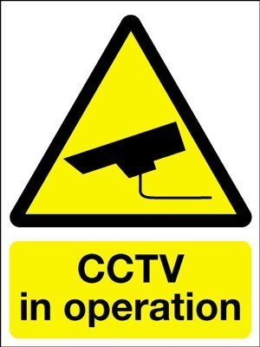
The controller of the images and personal information captured using the CCTV covered by this notice is Hutton Cricket Club The images and personal information are captured using our CCTV system for the purpose of security, crime detection, public safety and other legitimate reasons set out in our privacy notice.

This privacy notice can be found online at https://www.huttoncc.com/pages/page_35961/hutton-policies.aspx#CCTV or copies are available upon request. Please contact Hutton Cricket Club’s [Honorary Secretary by email at secretary@huttoncc.com or by post at Hutton Cricket Club, Hall Green Lane, Brentwood, Essex CM13 2QT or Telephone 01277 219864 if you would like a copy of this privacy notice sent to you, you have any queries or wish to exercise any of your rights in relation to your personal data. Please see the privacy notice for further details.

