
EXECUTIVE COMMITTEE MEETING MINUTES

Wednesday 7th October 2026

In the Chair: Trevor Atkinson

Other Officers Present: General Secretary – N Clee; Match & Registration Secretary – P Senior;
Administration Secretary – M Binns;

Life Vice Presidents: G Crompton; R Tindall

Club Representatives: (Grounds & Facilities Team) A Fortis; L Harrison; C McCreadie

Apologies

Treasurer - A Hill; President – W A Sugden; Compliance Officer – Mrs Jackie Brook; (EDI Chair) Mushtaq Hussain; Media Secretary – Mrs Paula Huddleston

Minutes of Previous Executive Meeting held on Wednesday 2nd September 2026

Approved.

Matters Arising

Special Announcement.

Due to family commitments W Andrew Sugden has indicated that he will step down from being HPCL’s President at the upcoming AGM in December. As a result of work undertaken to identify alternative arrangements, and having had exploratory discussions, Chair Trevor Atkinson recommended to the meeting that Mr David Hall of Shepley CC be nominated to succeed Andrew, and asked for the Executive’s approval and support.

The Executive Committee were unanimous in its support for this suggestion which will now be brought before the Council at the AGM.

Financial Report – TA (on behalf of AH)

The Report confirmed that the finances of the League are in a satisfactory state with General Funds totalling £61.5k.

The ECB Development Fund totals just over £17k.

Slaithwaite still owe £354 for their ball order.

2 clubs still to pay their 06 Jun to 01 Aug fines: - Birkby Rose Hill and Edgerton & Dalton. 3 clubs still to pay their 08 to 29 Aug fines: - Birkby Rose Hill, Clayton West and Edgerton & Dalton.

Disciplinary Report – MB

Follow up actions have now been taken against the two Clubs involved in HPCL’s T20 Trophy Final held at
Lascelles Hall CC in July. Disciplinary actions have also been taken against one player from Rastrick CC and two players/members from LH CC.

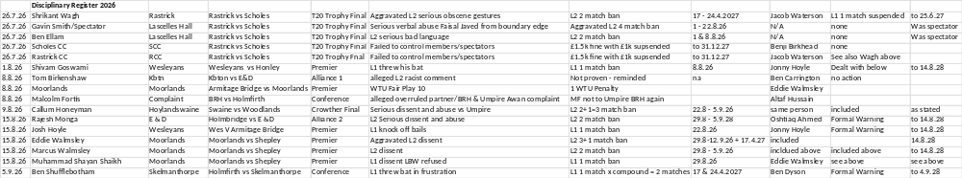

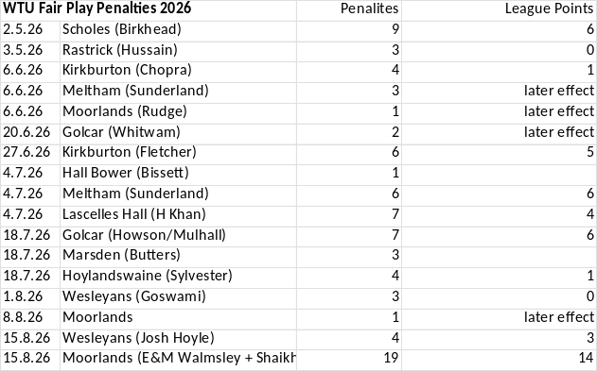

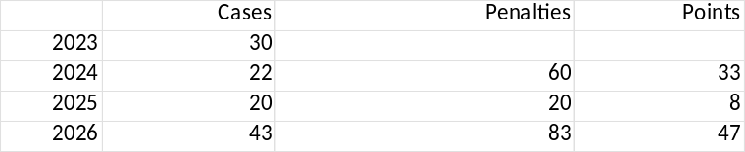

Media Secretary Report – PH (via MB)

A number of end of season articles have been placed on the website and launched on our social media channels.

Over the last six months Paula has established good contacts with several photographers and journalists. These will be very useful for the future.

Over the upcoming winter Paula will undertake a further review of the website and our social media activities to see what can be done to ensure its contents are suitable and provide good, relevant and interesting news and information to our cricket community. Any opportunities for improvement will be progressed, and any constructive feedback is welcomed.

EDI Report – MH via MB

MH is supporting the process of reviewing the situation at Linthwaite CC.

Clubmark, Safeguarding and Compliance – JB via MB

HPCL are in contact with ECB and YCF regarding the most up to date compliance situation at Linthwaite CC. YCF have informed HPCL that it will not reach its final conclusions until the end of the ECB Compliance year on 31st October 2026. Keeping in mind the information detailed in the ground and facilities report below the meeting agreed to try reach a final conclusion regarding Linthwaite CC at our next meeting in November.

The other remaining concern relates to Delph & Dobcross CC who have been one team short of junior hardball compliance, and with having acceptable arrangements in place to meet their obligations for girls cricket.

Shelley CC’s gap closure action plan has been approved and is on track.

Match & Registration Secretary Report - PS

The final Fines List of the 2026 playing season is attached to these Minutes.

The winners of the Hopkinson Trophy and Schweppes Cup, that is awarded to the 1st XI and 2nd XI teams acquiring most points in last six league matches of the season are respectively: Thongsbridge CC and Lascelles Hall CC.

The Jack Gledhill Memorial Trophy, that is awarded to the best all-round cricketer of the year, was won by Hoylandswaine CC’s Samit Patel.

The Reg Haigh Trophy, awarded to the League’s most promising young cricketer, was won by Honley CC’s Harry Moore.

The Johnny Hunter Rose Bowls, awarded to a 1st and 2nd XI cricketer for securing the best match winning performances of the season, were won by:
- 1st XI – Abbas Khan of Marsden CC
- 2nd XI – Isaac Davis of Delph & Dobcross CC

The David Boulton Memorial Trophy, awarded to the most sporting team of the year, was won by Slaithwaite
CC’s 1st XI.

The F E Greenwood Trophy, awarded to a Club whose ground is of a high standard, and where improvements to its playing area and amenities have been made, was won by Upperthong CC.

The Tom Walker Award, that goes to the groundsman of the year, was won by Josh Ellis of Emley Clarence CC.

The Tim Sugden Administration Award was won by Thurstonland CC.

Grounds and Facilities - AF

AF updated the meeting on the third audit visit that took place at Linthwaite on Monday 5th October. Some further improvements have been made. Most of the essential H&S items have been made good. However other matters remain outstanding.

Audits of other Clubs are ongoing. Priorities are Flockton CC, Edgerton & Dalton CC, Denby Grange CC.

Any Other Business

The 2026 season WTU Fair Play marks will be circulated asap.

Possible Rule Changes for 2027 are being compiled and will be discussed in detail on Friday 9th. The working party set up to explore the possibility of a Player Points Cap System (PPCS) continues to study options and consult with key stakeholders.

Work to study options designed to improve the strength and quality of Umpires for 2027 will begin shortly.

Please note: The next meeting of HPCL’s Executive Committee will take place at Almondbury Wesleyan CC on Wed 4th November 2026 commencing at 19.00pm

