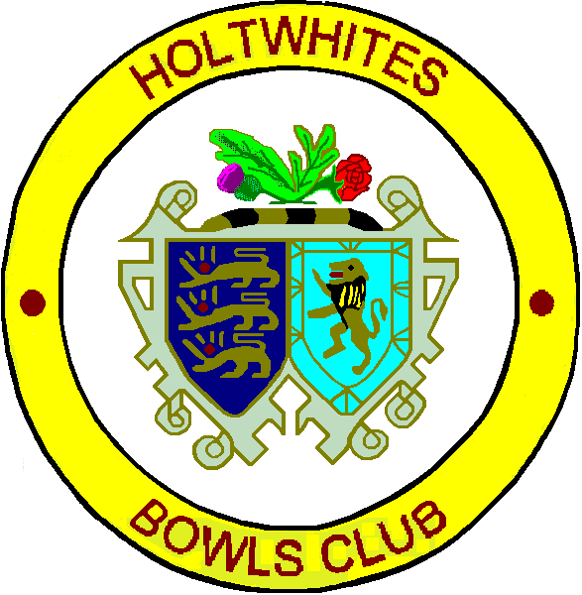 

**Centenary Celebration Game.**

**Holtwhites Bowls Club**

**V**

**Bowls England**

**19th June 2015**

12.00pm Arrival of teams.

12.30pm Arrival of The Worshipful the Mayor of the London Borough of Enfield, Councillor Pat Ekechi.

12.30pm Arrival of guests and the welcome speech followed by a finger buffet.

1.15pm Opening of the Centenary garden.

1.20pm Club photographs.

1.30pm Start of the game.

5.30pm Evening meal.

Holtwhites Bowls Club would like to thank distinguished guests,

Bowls England, our sponsors, students from Capel Manor College

and all its members for making this such a special occasion.