1st XI Team Captain reports

For the 2021 season we will be changing how the captains reports are submitted. We will be using Play Cricket to collate the umpires reports so as to help get as many reports submitted as possible by captains.

The instructions for doing so are described below and in the Play Cricket helpdesk article: https://play-cricket.ecb.co.uk/hc/en-us/articles/115003502445-Team-Captains-Umpires-Reports-Club-

Site administrators may see a pending workflow item on their site’s Admin Home page - ‘Team Captain Reports Requiring Completion’.
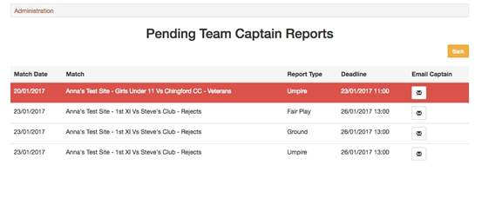
When the deadline for submission of a report is approaching, or has passed, the pending report will appear in red on the final date that the report is due for submission.
Chaser emails (one per report) are sent out automatically and the option to email a team captain manually is also available.
The system generated chaser email will be sent to the following people at the club marked as being responsible for completing the report:
- The player identified as team captain in the fixture’s team sheet.
- If different from 1, the player identified as team captain in Teams admin.
- The Hon. Secretary from the About Us section of the club.
When a report has been submitted, the prompt is removed from the pending report list.

Team Captains Report Submission
There are three report types - fair play, ground, and umpires.
They will only be completed from club play cricket sites.
The requirement to complete the reports depends on the league administrator’s request. They may have asked for only the home team to submit a report.
Anyone who has a member of the website role with the club and is registered with Play-Cricket may login to the club’s site and select Team Captains Reports from the account dropdown list on a mobile device or PC.
The following screen shots have been taken from an iPhone:
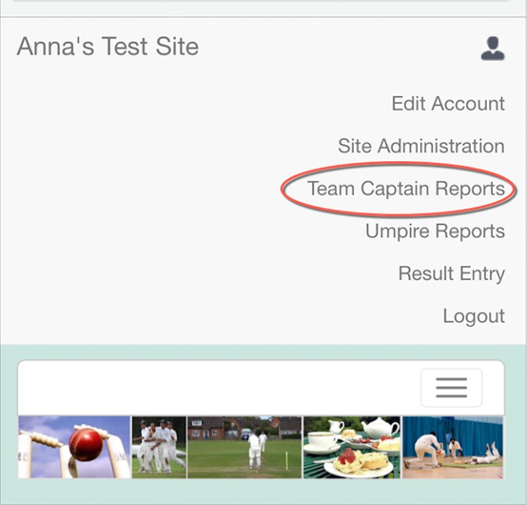
All matches requiring a team captain’s report are listed and the responder needs to make the correct selection.
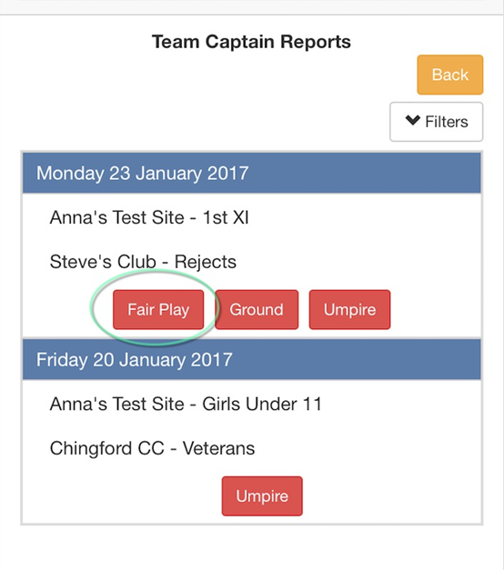
In this example, we have chosen to answer Fair Play questions.
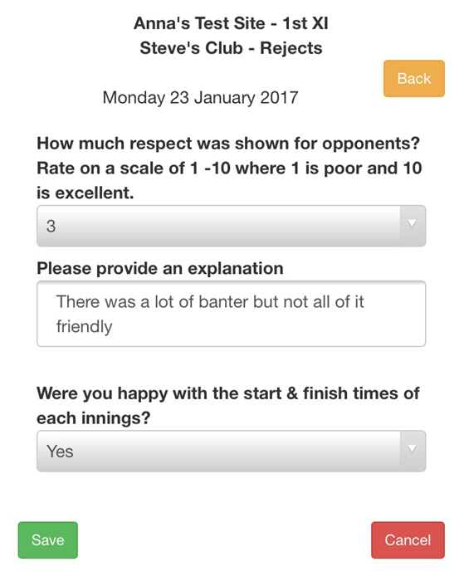
The answer given to the first question was below a threshold set by the league administrator so the button now appears in orange. This report will appear on a competition site as one requiring review.
Completed reports that do not need to be reviewed have a green button.
